CSA1717-ARTIFICIAL INTELLIGENCE
PRACTICAL LAB EXPERIMENTS
NIHARIKA PREEJESH (192524506)

PROGRAM 1: 8-QUEEN PROBLEM
Aim
The aim of this experiment is to solve the 8-Queens Problem using the Backtracking algorithm by placing eight queens on an 8 × 8 chessboard
Objective
To place 8 queens on an 8×8 chessboard so that no two queens attack each other.
Algorithm
Algorithm: SolveNQueens(Board, Column)
Step 1: Start.
Step 2: Initialize an empty 8 × 8 chessboard.
Step 3: Call SolveNQueens(Board, 0).
Step 4: If Column = 8, then
Display the chessboard.
Stop.
Step 5: For each Row from 0 to 7 do
If IsSafe(Board, Row, Column) = True then
Place Queen at (Row, Column).
If SolveNQueens(Board, Column + 1) = True then
Return True.
End If
Remove Queen from (Row, Column).
(Backtracking)
End If
End For
Step 6: Return False.
Step 7: End.
Source Code
# 8 Queens Problem using Backtracking
N = 8
board = [[0 for _ in range(N)] for _ in range(N)]
def is_safe(board, row, col):
# Check left side of current row
for i in range(col):
if board[row][i] == 1:
return False
# Check upper-left diagonal
i, j = row, col
while i >= 0 and j >= 0:
if board[i][j] == 1:
return False
i -= 1
j -= 1
# Check lower-left diagonal
i, j = row, col
while i < N and j >= 0:
if board[i][j] == 1:
return False
i += 1
j -= 1
return True
def solve(board, col):
if col >= N:
return True
for i in range(N):
if is_safe(board, i, col):
board[i][col] = 1
if solve(board, col + 1):
return True
board[i][col] = 0
return False
if solve(board, 0):
print("Solution Found:\n")
for i in range(N):
for j in range(N):
if board[i][j] == 1:
print("Q", end=" ")
else:
print(".", end=" ")
print()
else:
print("No solution exists.")
Flowchart
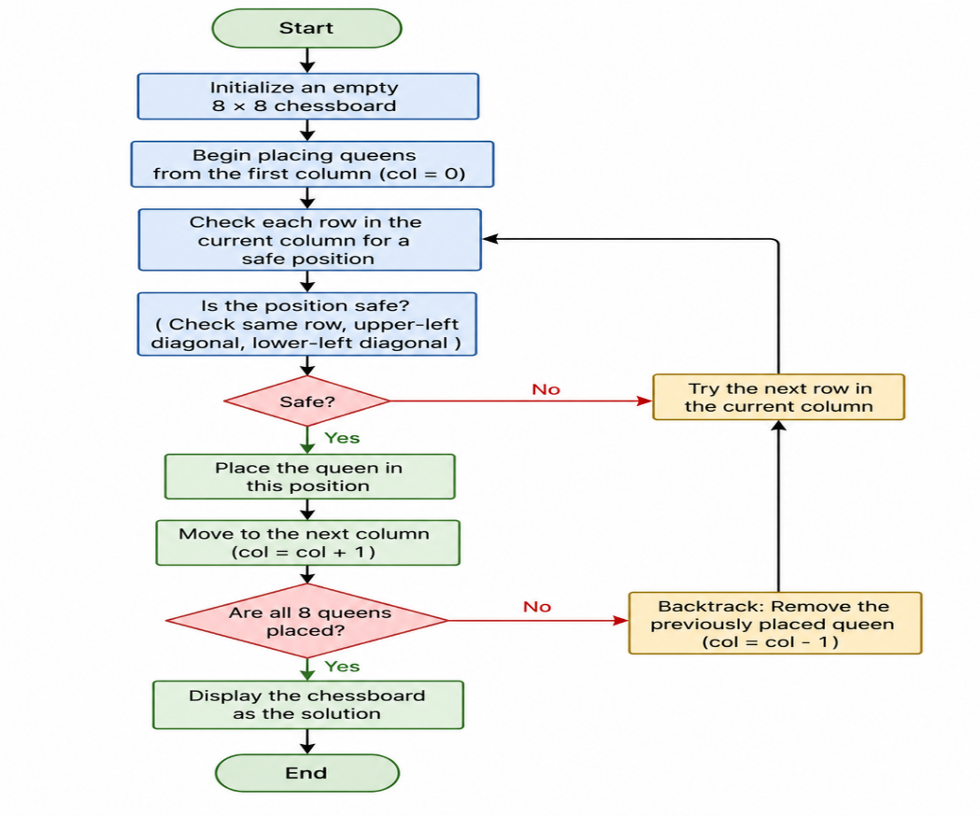
Output
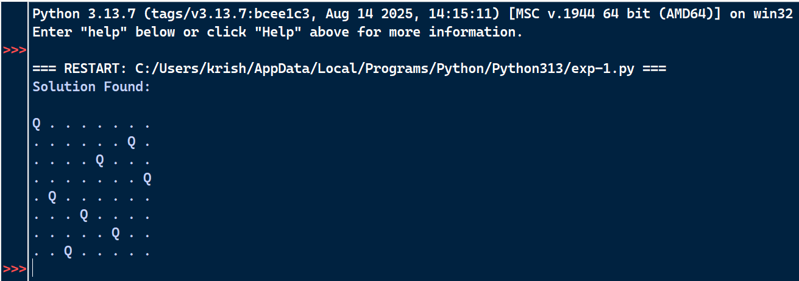
Result
Therefore the 8-Queens Problem was successfully solved using the Backtracking algorithm.

